JUnit Testing Exercises

Exercise 1: Setting Up JUnit:
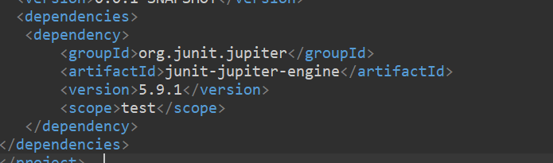

Exercise 3: Assertions in JUnit:
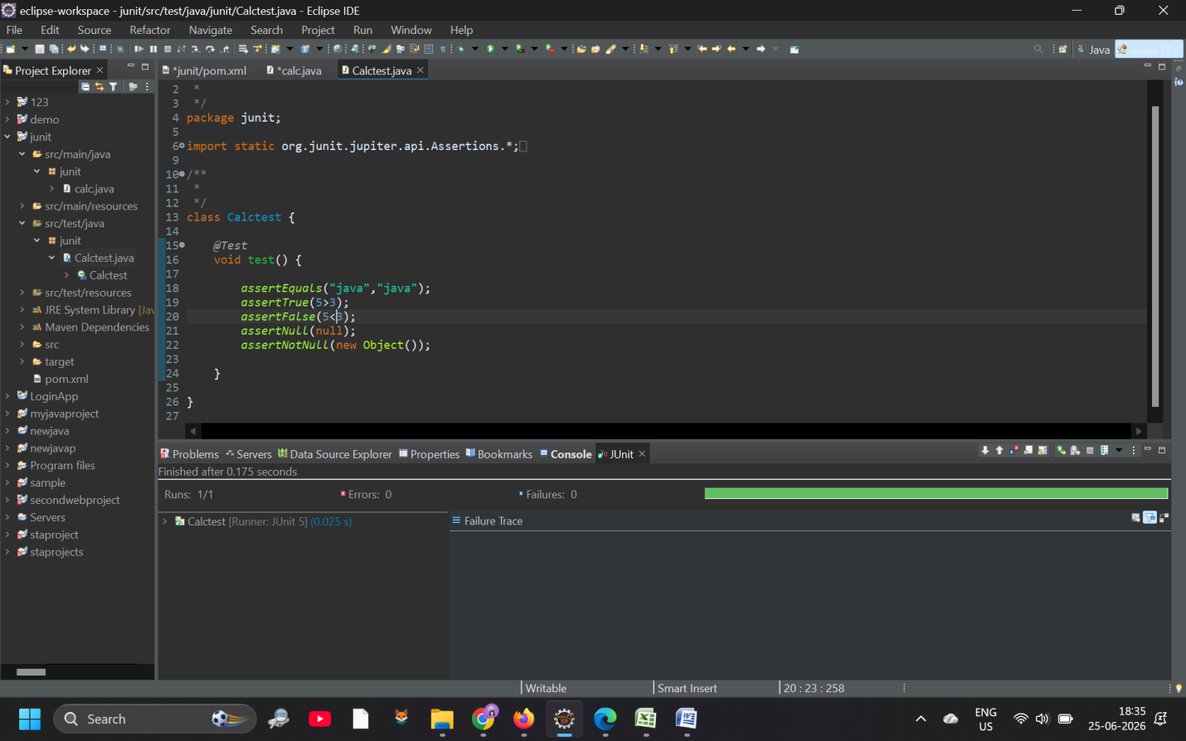

Exercise 4: Arrange-Act-Assert (AAA) Pattern, Test Fixtures, Setup and

Teardown Methods in JUnit
public class Calculator {
private int result;

public void add(int number) {
result += number;
}

public void clear() {
result = 0;
}

public int getResult() {
return result;
}
}

import org.junit.Before;
import org.junit.After;
import org.junit.Test;
import static org.junit.Assert.assertEquals;

public class CalculatorTest {

private Calculator calculator; // Test fixture object

// SETUP METHOD: Runs before EVERY individual test case
@Before
public void setUp() {
calculator = new Calculator();
System.out.println("Test environment initialized.");
}

// TEARDOWN METHOD: Runs after EVERY individual test case
@After
public void tearDown() {
calculator.clear();
System.out.println("Test environment cleaned up.");
}

@Test
public void testAdd_ShouldIncreaseResult_WhenPositiveNumberAdded() {
// 1. ARRANGE
int numberToAdd = 5;
int expectedResult = 5;

// 2. ACT
calculator.add(numberToAdd);
int actualResult = calculator.getResult();

// 3. ASSERT
assertEquals(expectedResult, actualResult);
}
}
